UI Naming Standards

Version 1.0

Revision History
Date | Version | Revision Details | Author(s) | Reviewer | Approver
6—09-2011 | 1.0 | Initial | Sneha R Krishnan  Rosemin D Kalliath | Pradeep

Document Control

Distribution

Holder’s Name | Holder’s Designation | Issue Date
Pradeep | Project Manager

Table of Contents

1. Objective 4
2. Scope 4
3. Definitions Acronyms and Abbreviations 4
4. Page LAYOUT CLASSIFICATION 4
5 COMPLEX PAGE LAYOUT 6
6 gENERAL guidelines 7

Objective

This Document describes the Standard UI Naming conventions.

Scope

The scope of the document is to understand and follow the standard naming conventions Of UI

Definitions Acronyms and Abbreviations

UI – User Interface

Page Layout Classification

Header

Content

Footer

The page Layout is mainly classified into Header, Content and Footer as shown above. The container to hold the header, content and footer should be named as main.
The naming conventions for header, content and footer is as follows.

Header
The outer header section should be named as header. The elements inside the header should continue its naming as header_id01, header_id02 and so on. The common classes for the header section should be named as header_cl01, header_cl02 and so on

The menu section of the header can have its naming as header_nav. The elements inside the menu container should be named as header_nav_id01, header_nav_id02 etc.

The search section of the header will have the naming as header_ search for the search container.

The logo image will have the name as header_ logo.

Content
The container for the content section should be named as content. The elements inside the content should follow the naming as content_id01, content_id02 and so on .If the content has three different sub sections, the sub sections can be named as contenteft_id01, contentmidd_id01, contentright_id01.

NB: The content section naming vary based on the page layout of the projects.

Footer
The outer footer section should be named as footer. The elements inside the footer should follow the naming as footer_id01, footer_id02 and so on. The common classes for the footer section should be named as footer_cl01, footer_cl02 etc.

Complex Page Layout
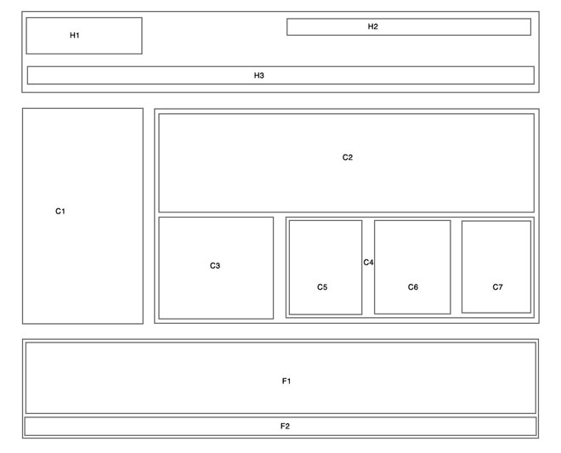

A sample complex page layout is shown above. In the figure, the blocks represent the containers of the page.
5.1 H1, H2 & H3
The H1, H2, H3 represents the containers in the header section. As these containers will be present only once in the same HTML page and we can use id’s for that.
H1 is usually placed to position the logo image and its container id is named as “header_logo” and the styles inner to it is named as “header_logo_id01” and class named as “header_logo_cl01”.
H2 indicates the search portion and container id named as “header_ search” and the styles inner to it is named as “header_ search _id01” and class named as “header_ search _cl01”.
H3 indicates the global navigation section which is denoted with id “header_nav”, and the inner sections of the header nav can be named as “header_nav_id01” and class is named as “header_nav_cl01”.
5.2 C1, C2, C3, C4, C5, C6, C7
The C1 – C7 indicates the content portion. These sections should be named as
websitename_sectionname_idpp/clpp where,
websitename - should be the first 3 letters of the website name,for eg it will be here ‘web’.
sectionname - should contain the 6 to 8 characters of the section which should be identifiable, for eg: If the section name is store products then naming should be ‘storeprod’.
idpp/clpp – indicates the number of the id or class.’pp’ can be 01, 02...etc
So in general ‘web_storeprod_id01’ will be the name of a section.
The sub sections coming within the main sections should be named accordingly.
For eg: If C4 main section is named as ‘web_storeprod_id04’, then the sub section C5 should be named as ‘web_storeprod_id05’, C6 should be named as ‘web_storeprod_id06’, and C7 should be named as ‘web_storeprod_id07’.
5.3 F1 and F2
F1 and F2 indicate the footer section. The F1 is named as ‘footer_id01’. The F2 named as ‘footer_id02’.

General Guidelines

Use of Ids and classes
The unique containers should use id’s and those which needs to be reused for a same page must use classes.

For every html page it should contain one main container with id #main and the header section with id #header, content section with id #content, and footer section with id #footer.

In projects where the client suggests the naming conventions, we need to follow that as per their requirement.

The standard width of the html is taken as 960px.

The id and class names must be written in lower case.
For e.g. id of the main container is written as id=”main”

6.2 Use of font classes

The common color used for the entire website can be given for the body. The other common colors and font sizes can be given inside a font class. The naming conventions for font classes are font_cl01, font_ cl02 etc. The common font classes should be written after the reset.css in the Style sheet.

Comments for HTML and CSS

The Comments play a vital role in both HTML and CSS should be simple and meaningful. Comments for the HTML page should be given only for the main containers, but for CSS the comments should be specified for each id’s and classes used. A style sheet and HTML page created should specify the following details like the document name, created date, author’s name and description of the page.

/*
Document : Document Name
Created on : Jul 7, 2011, 12:39:28 PM
Author : Name
Description : Short description of the page
*/

Importance of Using Reset .CSS

A reset style sheet removes and neutralizes the inconsistent default browser styling settings .It clears all default margins, padding, font styling, table properties, list styles, and so on. The reset styles should be included in the beginning of the style sheet.

6.5 Spacing and Alignment

Proper spacing and alignment has to be done for HTML page and style sheet.

Cross browser Testing

The created HTML pages should be cross tested in all different browsers .The main browsers are IE, Firefox, Chrome and Safari. The pages should behave exactly the same in all browsers.

HTML Validation Testing
The HTML pages developed should be tested in W3C HTML validator which is a free service validator that helps check the validity of Web documents. Validating Web documents is an important step which can dramatically help improving and ensuring their quality and it can save a lot of time and money.

